
Dr. APJ ABDUL KALAM SCHOOL OF ENGINEERING
DEPARTMENT OF ENGINEERING

NAME OF THE STUDENT: BARSHARANI PADHI
ROLL NO.: 24BTCE104 SEC:“A”
BRANCH: BTECH IN COMPUTER SCIENCE
COURSE: ADVANCE JAVA
ASSIGNMENT: 02
DATE ISSUED: 21/08/2026
DATE OF SUBMISSION:21/08/2026

Question: Develop a Student Registration and Validation System using Java Servlets, JSP, and JSTL. The application should provide a registration form through which students can enter their name, email ID, and course details.

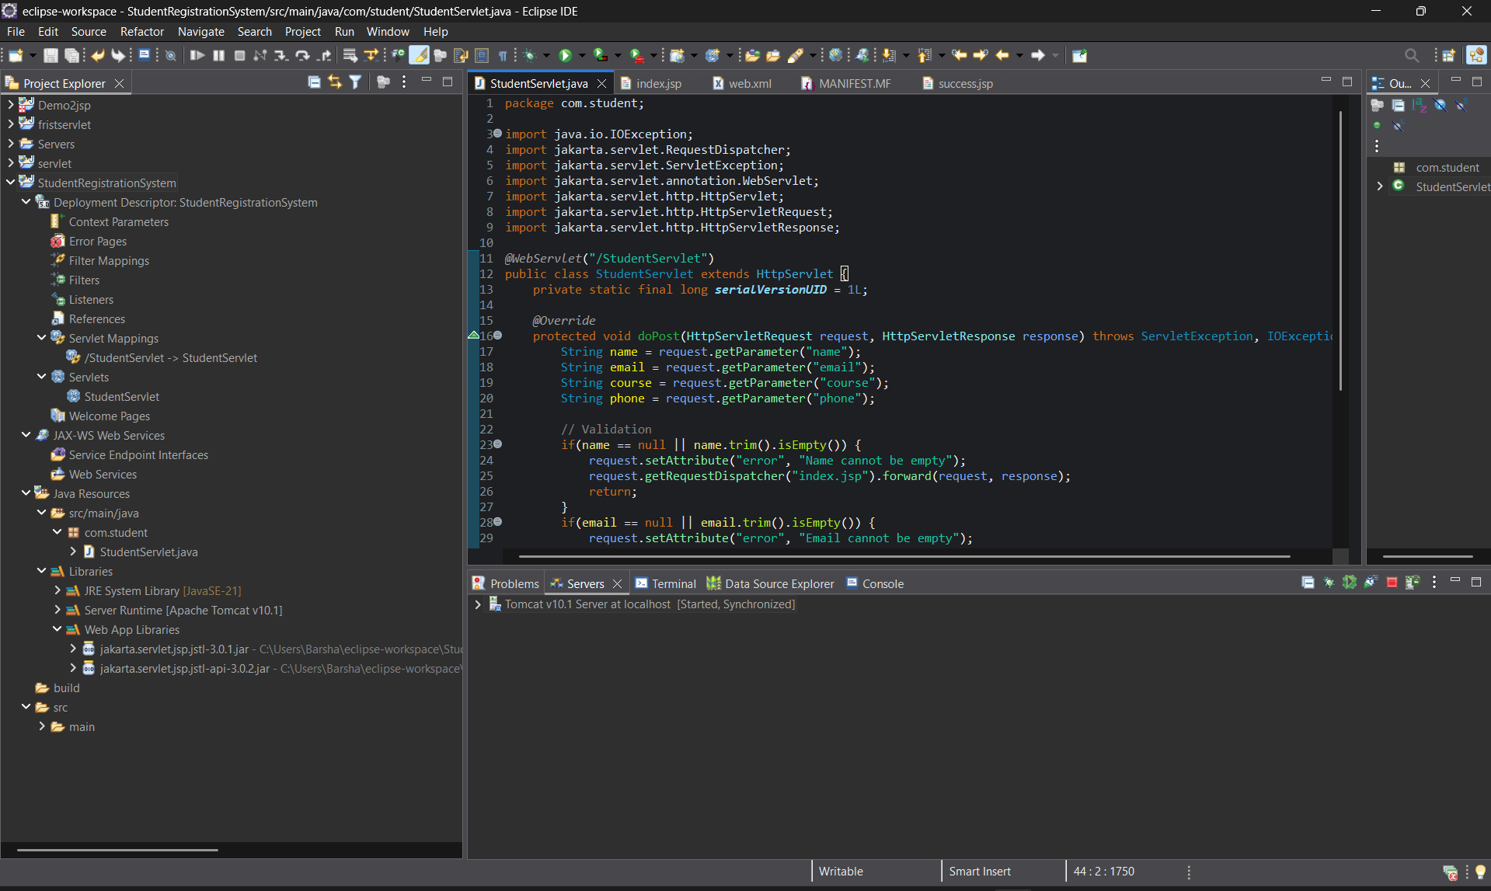
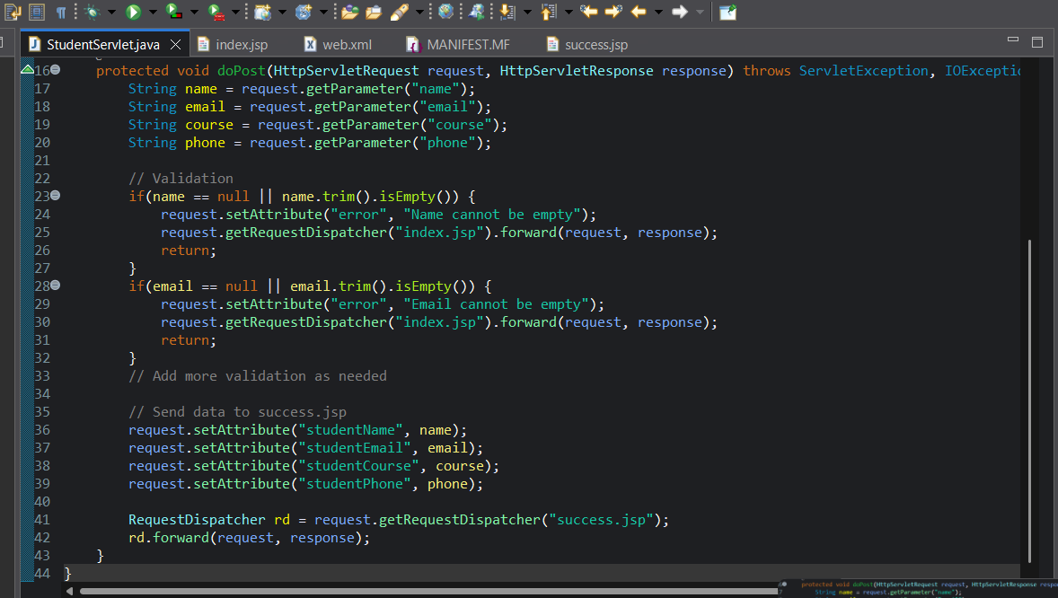
index.jsp:

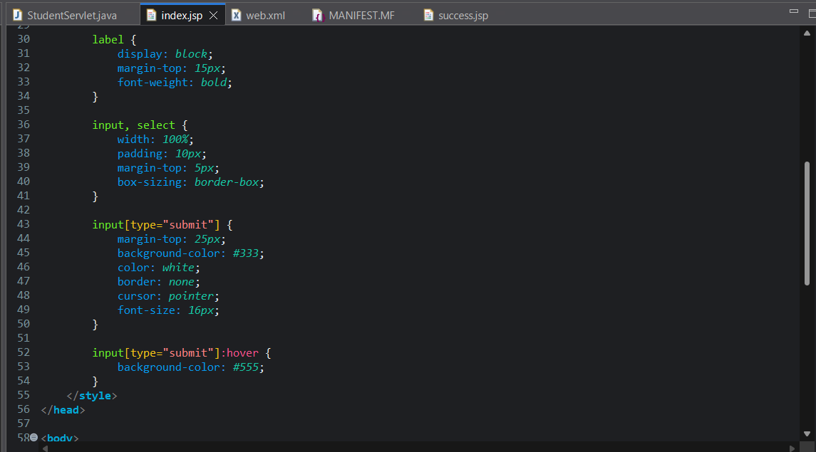
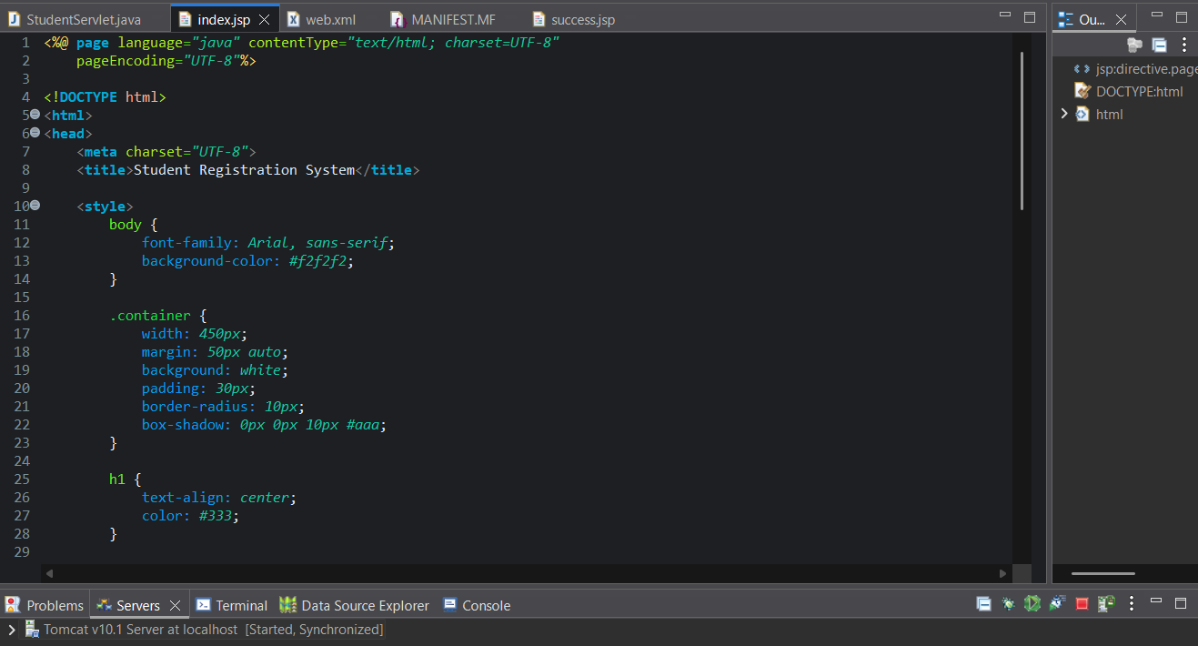

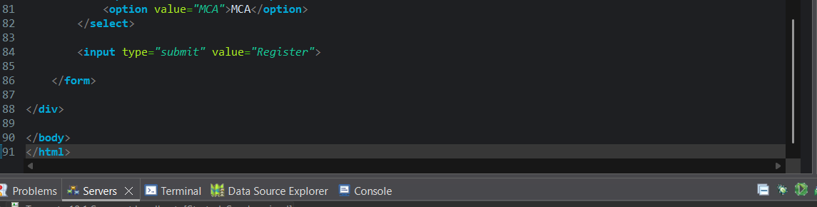
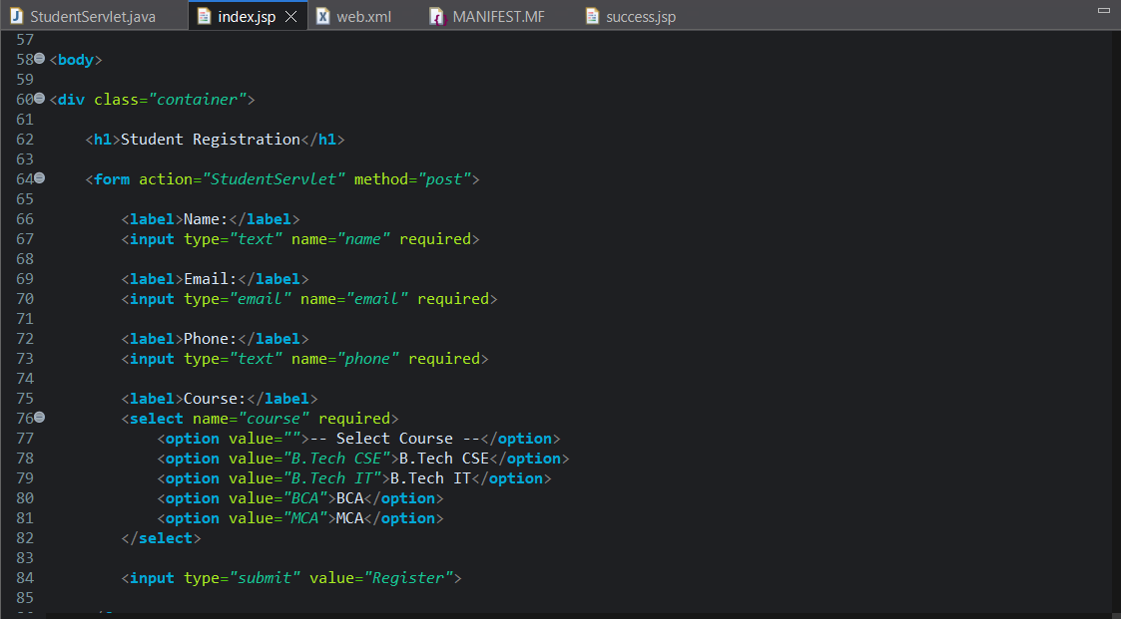

success.jsp:

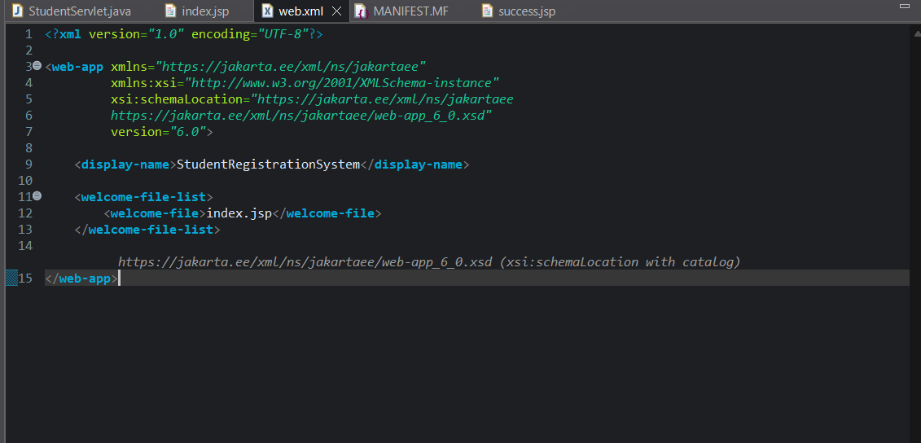
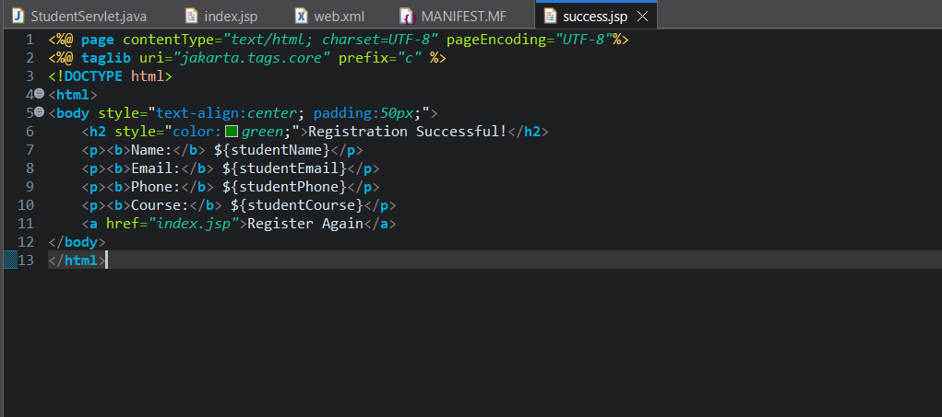
web.xml:

OUTPUT:

